**Step 1 :** **Create new jobs**

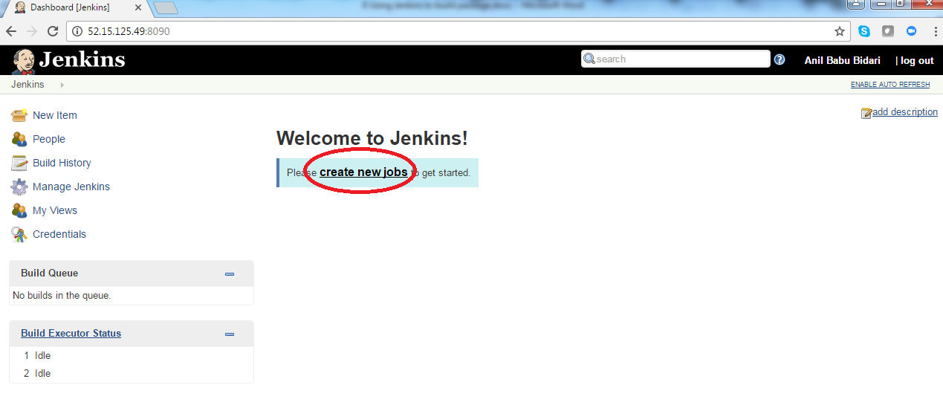

**Step 2 :** **Name your project as “webapp” , select “freestyle Project” and click ok**

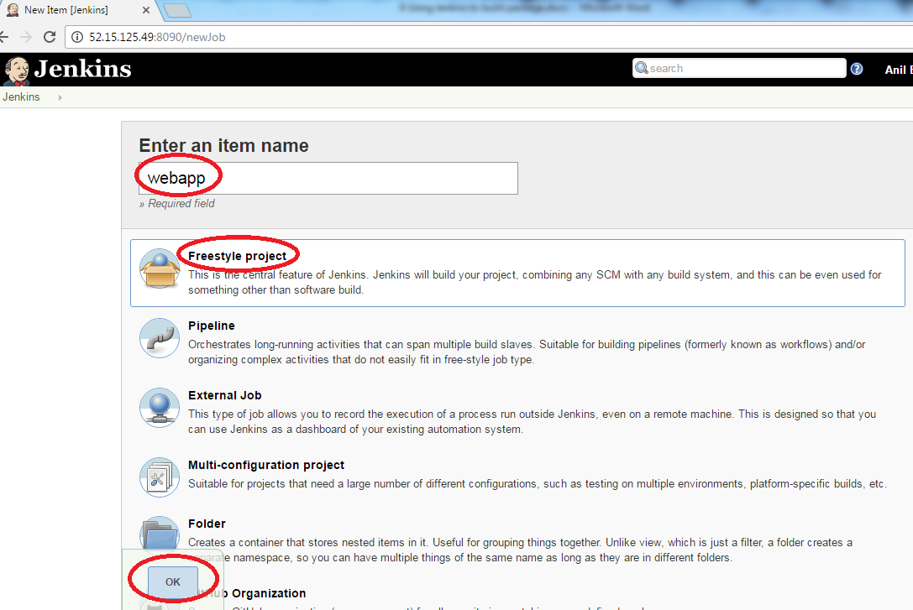

**Step 3 :** **click on “Source code Management”**

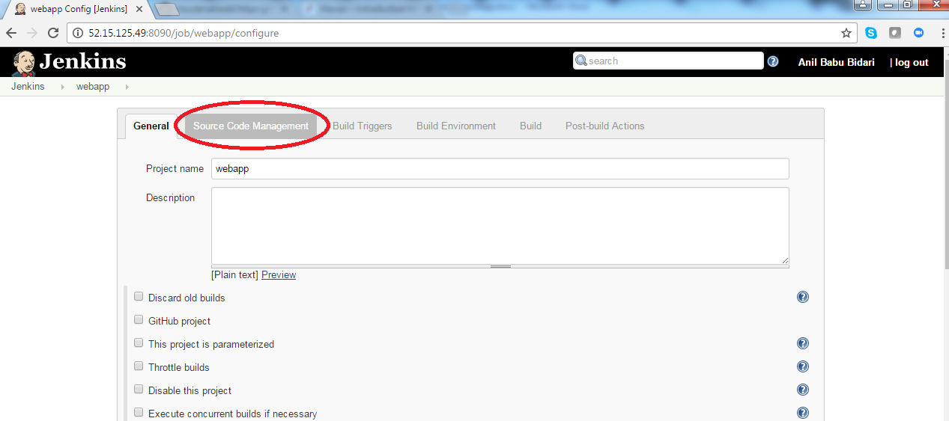

**Step 4 :** **Choose Git and add git url**

**https://github.com/anilbidari/https-github.com-g0t4-jenkins2-course-spring-boot.git**

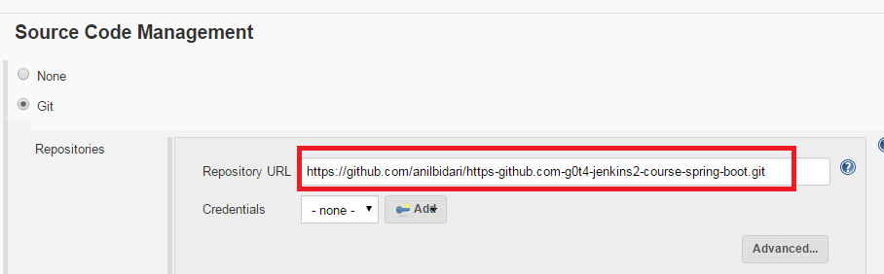

**Step 5 :** **Click on “#2 of your build history”**

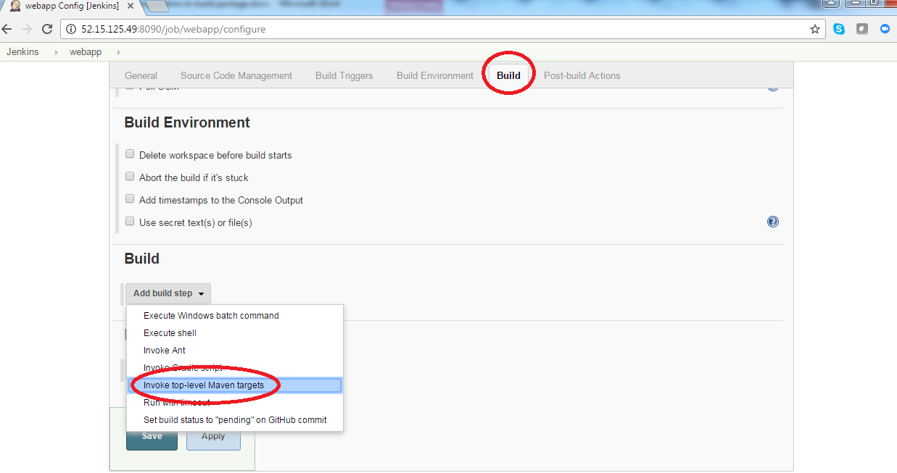

**Step 6 :**  **Set your goals as compile and click Advanced and provide pom.xml location**

spring-boot-samples/spring-boot-sample-web-static/pom.xml

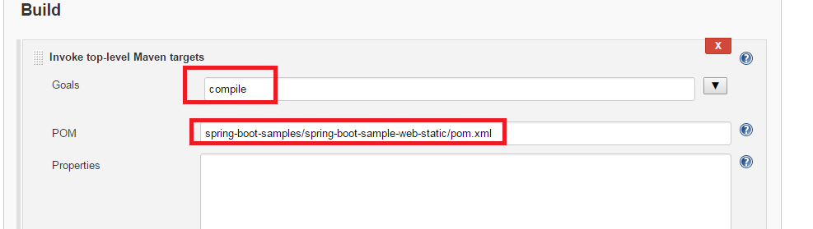

**Step 7 :**  **click on build now**

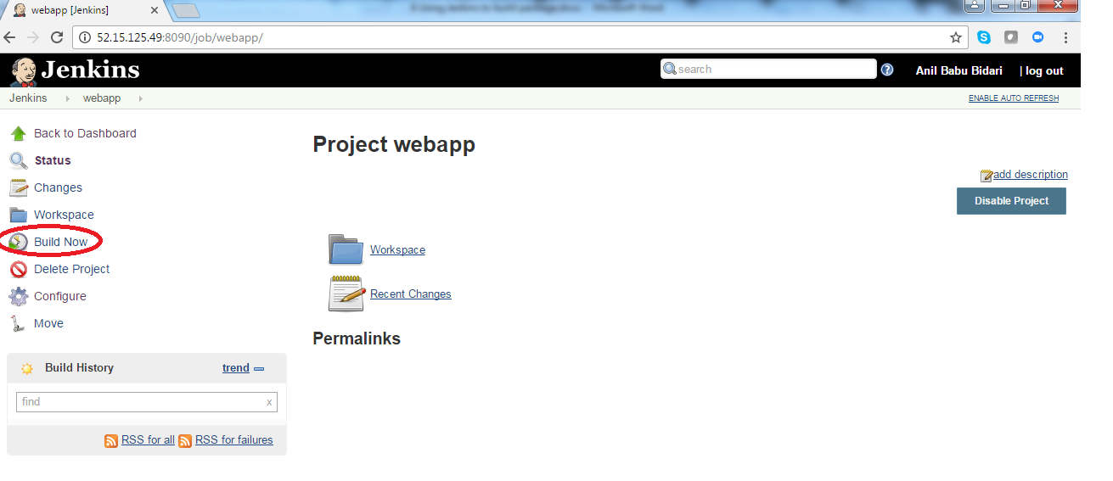

**Step 8 :**  **click on build history #2 or #1 based on your build**

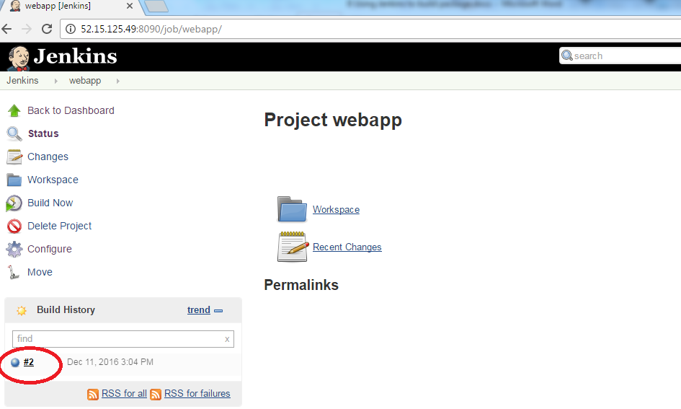

**Step 8 :**  **click on console output**

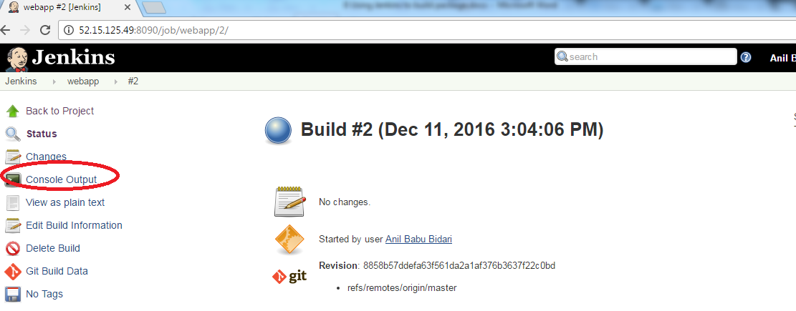

**Step 9 :**  **observe the location of your code and maven compile gets executed**

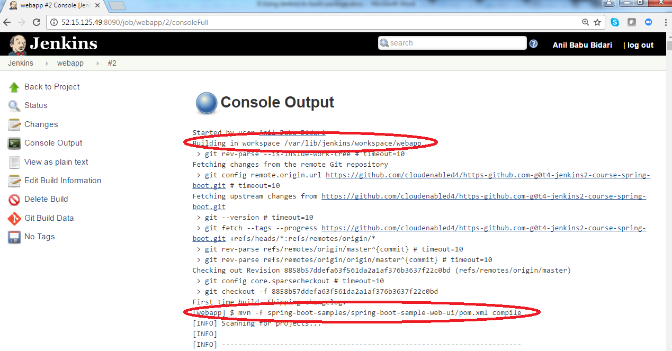

**Step 10 :**  **ssh to your machine and observe the output**

cd /var/lib/jenkins/workspace/webapp

ls -l

